**Instructions for Follow-up in the MISTRAL Study**

**Follow-up 1, Autumn 2023**

Instructions for Follow-Up in the MISTRAL Study 3

General information: 4

Case definitions: 4

The MISTRAL Follow-up form (FU 1 Autumn 2023): 4

The Cause of Death (CoDe) event form 5

The RESPOND Event Form 5

REDCap instructions for Follow-Up in the MISTRAL Study 6

ACCESS TO REDCap 7

FIND YOUR PROJECT 7

FIND A PATIENT FOLLOW-UP FORM/PATIENT RECORD 7

ENTER DATA INTO THE PATIENT FOLLOW-UP FORM/PATIENT RECORD 10

FINALIZE EACH PATIENT RECORD 13

SAVE OR PRINT RECORD FOR YOUR OWN USE. 13

ADD NEW PATIENT RECORD 13

List of Definitions for Clinical Events for the MISTRAL Study 15

LIST OF DEFINITIONS 16

Reimbursement Rates for the MISTRAL Study 18

MISTRAL Reimbursement Rates 19

# Instructions for Follow-Up in the MISTRAL Study

**Follow-up 1, Autumn 2023**

Please study these instructions and the list of definitions for the various diseases before you start entering data into the REDCap forms.

General information:

The EuroSIDA follow-up in REDCap now consists of the following forms:

* The MISTRAL Follow-up form (FU1 Autumn 2023): For all non-EuroSIDA patients enrolled into MISTRAL
* Cause of Death (CoDe) event form: For all patients who died.
* The RESPOND Event Form: For patients who have had a bone fracture, AIDS or non-AIDS defining cancer, end stage liver disease (incl. liver transplantation), end stage renal disease (incl. renal transplantation), myocardial infarction, invasive cardiovascular procedure or stroke since last follow-up (DS50).

Access to REDCap forms:

Detailed instructions for REDCap may be found below.

Historically reported data has been pre-uploaded to the MISTRAL follow-up form. Kindly make sure that you complete all forms for all uploaded participant forms.

All principal investigators should have received a username and password for REDCap by email. If you or anyone from your team need access to [REDCap](https://www.chip-crf.info/redcap/) or have questions regarding the follow-up forms, please contact the coordinating centre: [mistral.rigshospitalet@regionh.dk](mailto:mistral.rigshospitalet@regionh.dk).

Case definitions:   
  
Please find the “List of Definitions on Clinical Events” for AIDS defining diagnoses (except malignancies) enclosed in this document or find it on the EuroSIDA website. The updated Manual of Operations of Clinical Events can be found on the EuroSIDA website as well <https://www.chip.dk/Studies/EuroSIDA/Study-documents>

The MISTRAL Follow-up form (FU 1 Autumn 2023):

The follow-up form will only be available for those non-EuroSIDA patients that had a MISTRAL enrolment form fully completed by you and locked by us prior to 1st July 2023.

Please complete all requested information for all patients.

**Present visit:**

Please enter the date of the present visit (i.e. the data of the patient’s most recent clinic visit).

If the patient has not been seen within the last 12 months, please indicate why. You may then leave the remaining sections blank and continue straight to the final “Status” section. If the patient has died, please complete the Cause of Death (CoDe) event form. If the patient has been seen since last follow-up, please make sure to complete all sections in the follow-up form.

**Events:**

Please see the “List of Definitions on Clinical Events” for the relevant events collected in MISTRAL. If a new event has occurred since last follow-up, please report the event and the date of event in the follow-up form. If the patient has had a bone fracture, AIDS or non-AIDS defining cancer, end stage liver disease (including liver transplantation), end stage renal disease (including renal transplantation), myocardial infarction, invasive cardiovascular procedure, or stroke since last follow-up (DS50), please follow the link in the FU form to complete the RESPOND Event Form.



**The ‘Status’ section must be completed for *all* patients** when all available data has been entered. By completing this form, you indicate that all available data has been entered and that the follow-up form is complete.

The Cause of Death (CoDe) event form

Please provide the date of death and a brief narrative of the sequence of events leading to death. Please provide a summary of the causal relation between the conditions leading to death and upload any relevant source documentation (e.g. admission letter for the admission related to death, a discharge letter, an autopsy report or the like).

The RESPOND Event Form

Please complete the event form for patients who have experienced one or more of the following events:

* Bone fracture
* Cancer – AIDS and Non-AIDS defining
* End stage liver disease or liver transplantation (ESLD)
* End stage renal disease or kidney transplantation (ESRD)
* Invasive cardiovascular procedure (ICP)
* Myocardial infarction (MI)
* Stroke

Please see the Manual of Operations (MOOP) for clinical events in RESPOND and EuroSIDA for the definition of the individual events.

Note: The date of the event should still be indicated in the Follow-up form, but further details are collected in the separate REDCap RESPOND event form.

# REDCap instructions for Follow-Up in the MISTRAL Study

**Follow-up 1, Autumn 2023**

ACCESS TO REDCap

Enter the address: <https://chip-crf.info/redcap/> into your browser and log in with your username and password. If you have lost your username/password or if you have not received one yet, please write to the MISTRAL e-mail: [mistral.rigshospitalet@regionh.dk](mailto:mistral.rigshospitalet@regionh.dk).

The first time you log on you will be asked to change the password and set up a password recovery question. Please note that access is personal, and if more staff at your site needs access, please contact [mistral.rigshospitalet@regionh.dk](mailto:mistral.rigshospitalet@regionh.dk).

FIND YOUR PROJECT

Go to **My Projects** tab and find the list of all forms

**MISTRAL Follow-up (FU 1 Autumn 2023):** Follow-up forms for all your patients should be completed in REDCap. The follow-up form contains several sections, which should all be reviewed and/or completed unless there are no new data since last follow-up. If there is no new information since last follow-up, please indicate the reason in section A, and then complete the section and the final status form.

|  |
| --- |
| *Note: That all ‘Must Provide Values’ must be completed (marked in the FU form with**, unless the patient is dead, lost to follow-up or has not been seen since last follow-up, indicated in Section A.* If there are no new values to enter in a given field, you should mark this with a ‘No’, and not leave the field blank. **Reimbursement will be based on completeness of ‘Must Provide Values’.** |

The following forms in REDCap should be completed in real-time. Study sites in MISTRAL provide information on their participants continuously in the following forms:

* **RESPOND Event Form**
* **Cause of Death (CoDe) Form**

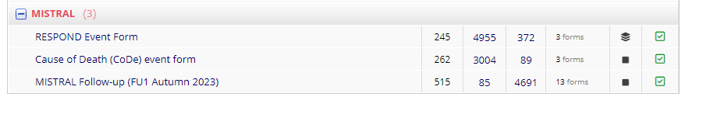

FIND A PATIENT FOLLOW-UP FORM/PATIENT RECORD

The MISTRAL Follow-up (FU 1 Autumn 2023)form has preloaded patients records with the historical information you have previously recorded in enrolment forms. Preloaded data is listed in grey fields. To find a patient record:

**1**. Click the projects MISTRAL Follow-up (FU 1 Autumn 2023). The project setup page will appear.

**2A**. Click **Record Status Dashboard** on the left-hand side under Data Collection   
  
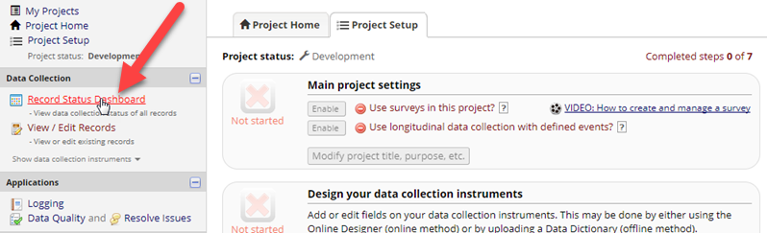

and then click the status icon for the patient and section you wish to edit.  
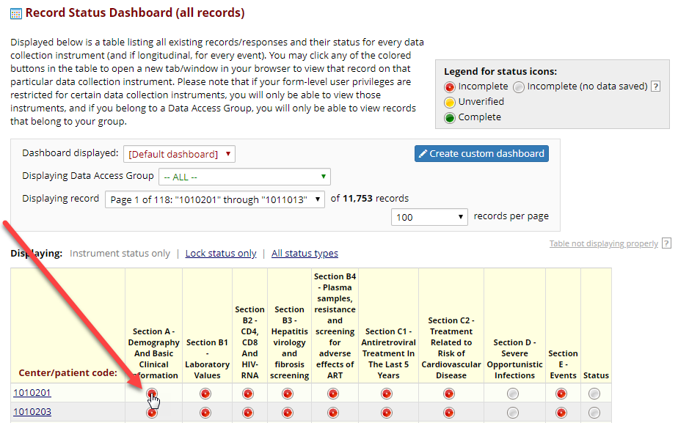

**2B**. Or click **Add/Edit Records** on the left-hand side under Data Collection   
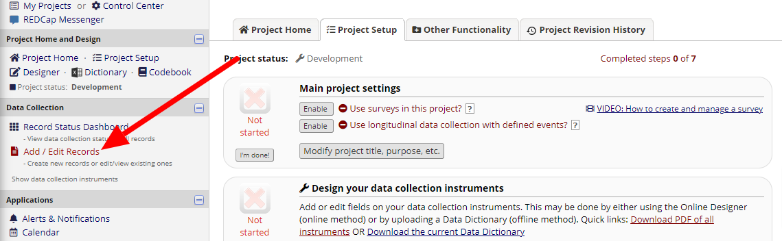

and find the record using the **Choose an existing Center/patient code** drop down box.

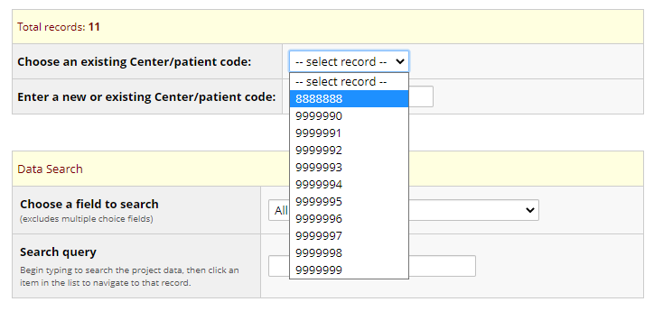

Or by entering the PID in **Enter a new or existing Center/patient code:**

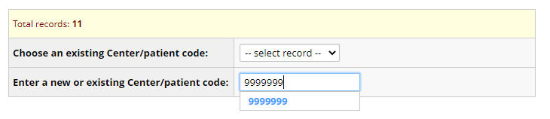

ENTER DATA INTO THE PATIENT FOLLOW-UP FORM/PATIENT RECORD

**1**. The MISTRAL Follow-up (FU 1 Autumn 2023) contains a form for each section. You can navigate between the different sections using the links on the left-hand side:

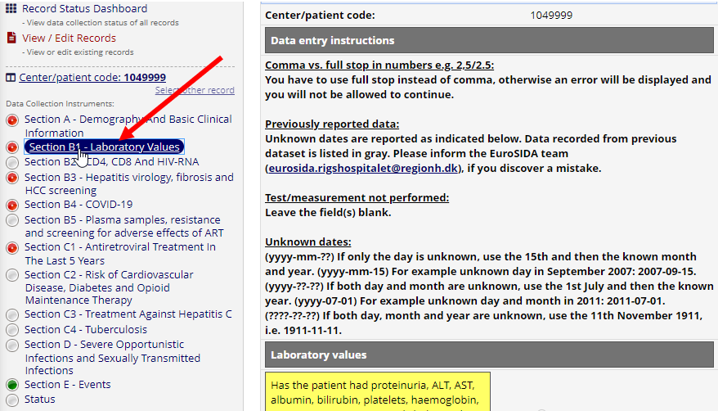

or the Record Status Dashboard:  
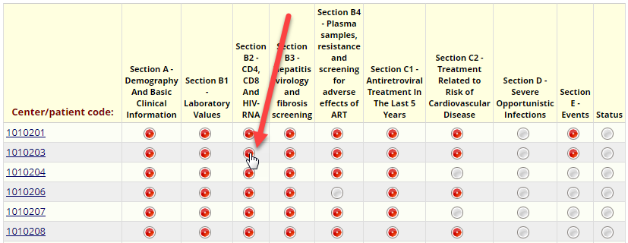

The colored icon in front of the form denotes the status, i.e.:

**Green** (complete): The form/section is complete.

**Yellow** (unverified): The form/section has been edited but is incomplete.

**Red** (incomplete): The form/section contains preloaded data and has not been reviewed and/or the form/section has been saved, but data is incomplete and will be completed/reviewed later.

**Grey** (incomplete): No data has been entered/saved.

**2**. Fill out the forms/sections. Data should be entered in the yellow fields. Previously reported data is displayed in grey fields. **You cannot edit previously reported data. If you find an error, please send an email describing the PID, section and the correction to the MISTRAL email** [mistral.rigshospitalet@regionh.dk](mailto:mistral.rigshospitalet@regionh.dk)**.** In some sections, e.g., section C1, the yellow fields are located amongst the grey field’s historical data.

To remove an answer, click **Reset**.

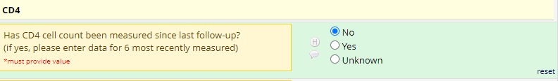

This screenshot shows you how to report that the patient has started new antiretroviral treatment:

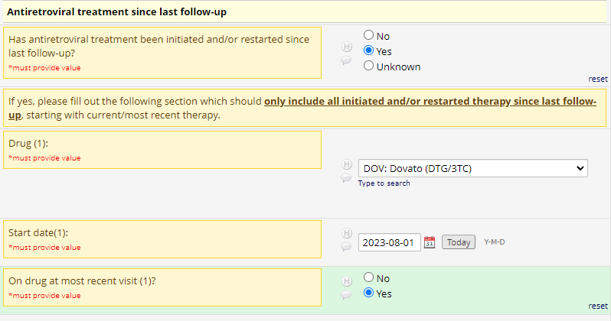

This screenshot shows you how to report that the patient has stopped antiretroviral therapy, which he/she was on at the last visit. Please indicate date of and reason for stopping: 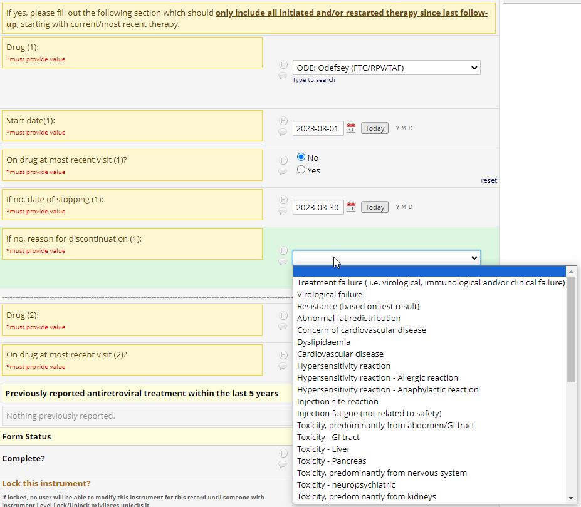

Comma vs. full stop

You have to use full stop instead of comma. Otherwise, you will receive this error:

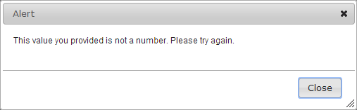

**3**. Select status at the bottom of the form/section.

**Incomplete**: The form/section contains incomplete data and will be completed later.   
**Unverified**: The form/section contains incomplete data and will be completed later. Please use this status if you are interrupted and need to come back to it later. Using this status will make it easy to find the form again via the Record Status Dashboard.  
**Complete**: The form/section contains all available data.

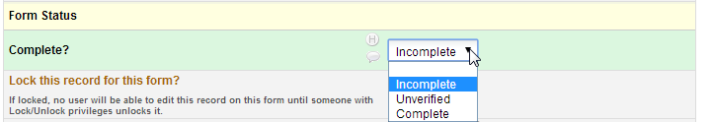

**4**. Click **Save & Exit Form**, **Save & Stay** or **Save and go to Next Form**.

FINALIZE EACH PATIENT RECORD

Before finalizing a patient record, please make sure that you have

* entered all data available for the patient
* if no new data is available, please make sure that “no new data” information is provided, e.g.:

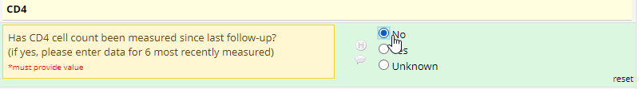

* If the patient has died and no new data is available *or* if the patient has not been seen since last follow-up, please indicate this in Section A of the Follow-up form and complete the final Status Section.
* Completed all sections in all applicable forms

Please click “Status” in the left side menu and confirm that you have finalized your data collection by choosing “Complete” in the dropdown menu. By changing the status of this form to **"Complete"** you confirm that there is no more available data for the patient during the current follow-up period.

SAVE OR PRINT RECORD FOR YOUR OWN USE.

If you wish to download your reported data from REDCap, please contact the coordinating center at [mistral.rigshospitalet@regionh.dk](mailto:mistral.rigshospitalet@regionh.dk), detailing which forms or data you wish to download.

ADD NEW PATIENT RECORD

The RESPOND Event form and the CoDe form do not have preloaded patient record data - so you need to add a new record manually.

**To add a new record:**

**1**. Click one of the projects (i.e., RESPOND Event form or CoDe form). The project setup page will appear.

**2**. Click **Add/Edit Records** on the left-hand side under Data Collection.  
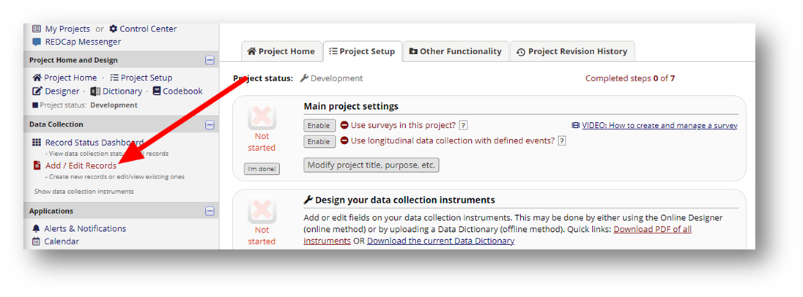3. Type the MISTRAL Patient Identification code [centre code (3 digits) followed by patient code (4 digits) e.g., 1502001] and press **ENTER**.

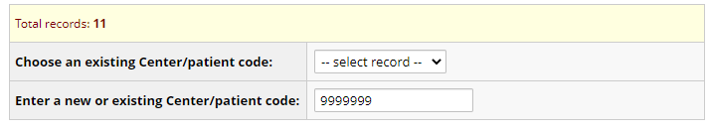

**4.** Click the circle under event 1 (only relevant for the Respond Event form).

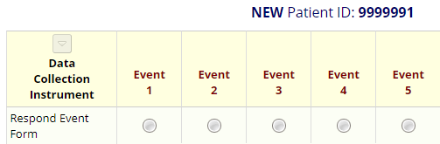

Choose the Event 1 by clicking here.

# List of Definitions for Clinical Events for the MISTRAL Study

**Follow-up 1, Autumn 2023**

LIST OF DEFINITIONS

Below, please find a list of definitions for the AIDS defining events collected in EuroSIDA. The diagnostic criteria and duration required for classifying as a “definitive” or a “presumptive” event are indicated (for opportunistic infections only). For the definitions of clinical events where completion of a RESPOND Event Form is indicated, please see the **Manual of Operations (MOOP) for clinical events** in RESPOND and EuroSIDA.

**Section D: Severe opportunistic infections**

DEM: AIDS dementia complex

Definitive: Disabling cognitive and/or motor dysfunction, and no other causes by CSF exam and brain imaging or by autopsy

Presumptive: Same as above, but no CSF and brain imaging performed

BCNE: Bacterial pneumonia, recurrent (> 2 episodes within 1 year)

Definitive: X-ray evidence of pneumonia not present on previous X-rays and culture of bacteria that typically cause pneumonia (other than *M. Tuberculosis*)

Presumptive: Acute radiological findings (new X-ray evidence not present earlier) and acute clinical findings

CANO: Oesophageal candidiasis

Definitive/autopsy: Gross inspection by endoscopy/autopsy or by microscopy (histology)

Presumptive: Recent onset retrosternal pain on swallowing and confirmed oral or pharyngeal candidiasis

CRCO: Cryptococcosis, extrapulm

Definitive/autopsy: Microscopy, culture of, or antigen detection in affected tissue

CRSP: Cryptosporidiosis (duration > 1 month)

Definitive/autopsy: Microscopy. Duration of diarrhoea for more than 1 month

CMVR: Cytomegalovirus retinitis

Presumptive:Loss of vision and characteristic appearance on serial ophthalmoscopy, progressing over several months

CMVO: Cytomegalovirus (pneumonia, oesophagitis, colitis, adrenalitis, other organs)

Definitive/autopsy: Microscopy (histology or cytology)

HERP: Herpes simplex ulcers (duration > 1 month) or pneumonia/oesophagitis

Definitive/autopsy: Microscopy, culture of, or antigen detection in affected tissue

HIST: Histoplasmosis (extrapulm.)

Definitive/autopsy: Microscopy, culture of, or antigen detection in affected tissue

WAST: HIV wasting syndrome

Definitive: Weight loss (over 10% of baseline) with no other cause, and 30 days or more of either diarrhoea or weakness with fever

ISDI: Isosporiasis diarrhoea (duration > 1 month)

Definitive/autopsy: Microscopy (histology or cytology). Duration of diarrhoea for more than 1 month

LEU: Progressive multifocal leukoencephalopathy (PML)

Definitive/autopsy: Microscopy (histology or cytology)

Presumptive: Progressive deterioration in neurological function and CT/MR scan evidence

MC: Mycobacterium MAC/Kansasii (extrapulmonary only)

Definitive: Culture

MCP: Mycobacterium tuberculosis, pulmonary

Definitive: Culture or PCR positive for Mycobacterium Tuberculosis

Presumptive: Smear positive for acid fast bacilli or a biopsy suggestive of Mycobacterium Tuberculosis by histology

MCX: Mycobacterium tuberculosis, extrapulmonary

Definitive: Culture or PCR positive for Mycobacterium Tuberculosis

Presumptive: Smear positive for acid fast bacilli or a biopsy suggestive of Mycobacterium Tuberculosis by histology

MCPO: Mycobacterium, other type (pulmonary)

Definitive: Culture (indicate type)

Presumptive: Smear positive for acid fast bacilli (species not identified by culture)

MCXO: Mycobacterium, other type (extrapulmonary)

Definitive: Culture (indicate type)

Presumptive: Smear positive for acid fast bacilli (species not identified by culture) on microscopy of normally sterile body fluid/tissue

PCP: Pneumocystis jirovecii pneumonia

Definitive: Microscopy (histology or cytology)

Presumptive: Recent onset of dyspnoea on exertion or dry cough, and diffuse bilateral infiltrates on chest X-ray and pO2 <70 mmHg and no evidence of bacterial pneumonia or viral pneumonia caused by SARS-CoV-2

SAM: Salmonella bacteraemia (non-typhoid) (> 2 episodes)

Definitive: Culture

TOX: Toxoplasmosis, brain

Definitive: Microscopy (histology/cytology)

Presumptive: Recent onset focal neurological abnormalities or reduced level of consciousness, and mass effect lesion on scan, and specific therapy response

# Reimbursement Rates for the MISTRAL Study

**Follow-up 1, Autumn 2023**

MISTRAL Reimbursement Rates

|  |  |
| --- | --- |
|  | **Reimbursement rates** |
| **MISTRAL Follow-up form** | 20 € |
| **CoDe form** | 30 € |
| **RESPOND event form** | 30 € |

*\*Please note that reimbursement is based on provision of a set of core data that should be available for all patients*